

ISSS602: Data Analytics Lab

Assignment 1: Show Me the Numbers

21 September 2025

NOR HENDRA BIN ABDUL RAHMAN
STUDENT ID: 01505038

Table of Contents
1. Objective 1
2. Data Pre-Look 1
3. Data Preparation 2
3.1. Pre-Checks 2
3.2. Temperature Anomaly 2
3.3. Date Time Checks 3
3.4. Weather/Season/Holiday Check 4
3.5. Season Sanity Check 5
3.6. Target Leakage of Users Count 5
3.7. Weekend Flag 6
3.8. Data Transformation 7
3.9. Binning of Variables 8
4. Data Analyses 9
4.1. Insight 1: Weather is a clear demand driver 9
4.2. Insight 2: Temperature Distribution differs by Weather 10
4.3. Insight 3: Humidity Profile differs by Weather 11
4.4. Insight 4: User and Humidity Association 12
4.5. Insight 5: Weather Composition Across Windspeeds 13
4.6. Insight 6: Mid-Range Plateau for Users vs Windspeed 13
4.7. Insight 7: Humidity and Windspeed Association, Temperature is Orthogonal 14
4.8. Insight 8: Humidity as Primary Driver, Comfort Band for Temperature, Windspeed with Mid-Range Plateau 15
4.9. Insight 9: Seasonal demand ordering tracks seasonal temperature; humidity and windspeed play secondary roles 17
4.10. Insight 10: Meteorology by Season: Big temperature shifts, modest humidity changes, small wind differences 18
4.11. Insight 11: Small weekend lead, higher single-hour peak on weekdays 19
4.12. Insight 12: Hour-matched comparison has no overall difference 19
4.13. Insight 13: Weekday vs Weekend – Registered Users Lead 21
4.14. Insight 14: Average Users Dominates Evenings, Morning ≈ Midday 22
4.15. Insight 15: More users on weekday mornings, no clear weekday and weekend gap in the afternoon. 23
5. Interpretation of Results: What Drives HappyRides? 25
6. Managerial Communication 26
6.1. Hourly Completeness 26
6.2. Precipitation 26
6.3. Thermal-Confort Indices 26
6.4. Event Calendar 26
6.5. Bike Dock Stations 26
7. References i

Figure 1: Distribution of Features 1
Figure 2: Summary of Pre-Checks 2
Figure 3: Code snippet for atemp anomaly (Assign1/1_DataPreparation/2_TempAnomaly.sas) 2
Figure 4: Results of atemp anomaly checks 3
Figure 5: Code snippet of missing hours (Assign1/1_DataPreparation/3_DateTimeCheck.SAS) 3
Figure 6: Code snippet of weather, season and holiday checks. (Assign1/1_DataPreparation/4_WeatherSeasonHolidayCheck.SAS) 4
Figure 7: Code snippet for season sanity checks. (Assign1/1_DataPreparation/5_SeasonSanityCheck.sas) 5
Figure 8: Code snippet for target leakage of users. (Assign1/1_DataPreparation/6_TargetLeakage.sas) 5
Figure 9: Results for Target Leakage 6
Figure 10: Code snippet for weekend flag. (Assign1/1_DataPreparation/7_WeekendFlag.sas) 6
Figure 11: Results of weekend flag script. 7
Figure 12: Data Transformation code. (Assign1/1_DataPreparation/8_FinalDataOutput.sas) 7
Figure 13: Average Users vs Weather(Categorized) 9
Figure 14: Levene Test and Welch's Anova 9
Figure 15: Temperature by Weather(Categorized) 10
Figure 16: Statistics for Temperature and Weather 10
Figure 17: Distribution of Weather Category by Humidity Binned, and its Statistics 11
Figure 18: Dot Plot of Average Users vs Humidity 12
Figure 19: Statistics from ANOVA test 12
Figure 20: Distribution of Weather by Windspeed Binned, and its Statistics 13
Figure 21: Average Users by Windspeed 13
Figure 22: Users by Windspeed ANOVA statistics 14
Figure 23: Mosaic plot for correlation 14
Figure 24: Statistics from Correlation Analysis 15
Figure 25: Code snippet for CDA prep (Assign1/3_Confirmatory Data Analysis/5A_HumiditySweepPrep.sas) 16
Figure 26: Average Users, Humidity by Temeprature/Windspeed 16
Figure 27: Distribution Count for testing <60% and >60% Humidity 17
Figure 28: Users by Seasons, with ANOVA Statistics 17
Figure 29: Meteorology by. Season box plots 18
Figure 30: Distribution count of Weekday and Weekend Users 19
Figure 31: Average Users by Hour, Weekday vs Weekend 19
Figure 32: Paired difference if weekend and weekday averages 20
Figure 33: Statistics from Paired Test 20
Figure 34: Data Prep for the paired t Test 21
Figure 35: Registered vs Users, Weekend and Weekday Distribution 21
Figure 36: Average Users by Peaks, and Statistics for Anova Tests 22
Figure 37: Heatmap of Average Users Day and Time 22
Figure 38: Data prep for morning vs afternoon/evening on weekday weekend. (Assign1/3_Confirmatory Data Analysis/9A_PeakShiftPrep.sas) 23
Figure 39: AM/PM vs Weekday Average - Weekend - Average 23
Figure 40: Statistics for AM/PM, Weekday - Weekend Average 24

Objective
The objective of this report is to quantify the drivers of HappyRides hourly demand using rigorously prepared data and SAS Viya analyses (EDA and confirmatory tests), and translate the findings into concise, evidence-based recommendations.

Data Pre-Look
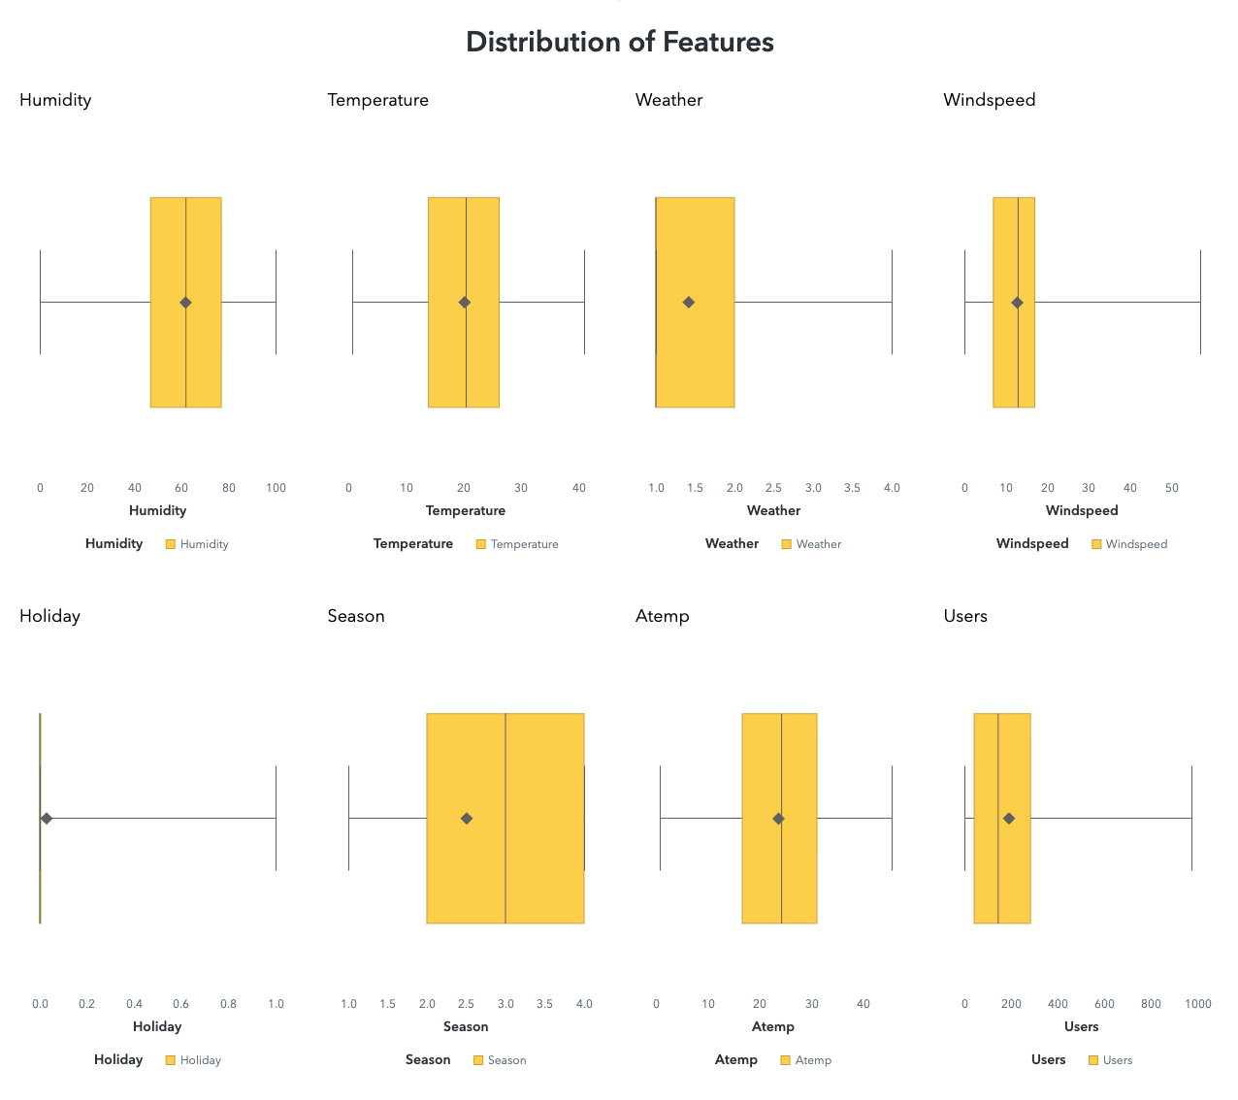
Figure 1: Distribution of Features
From the boxplot pre-look, the Users distribution is clearly right-skewed with a long upper whisker, indicating occasional high-demand hours that pull the mean above the median. Humidity is bounded yet concentrated around the mid-to-high range (roughly 50–75%), with a right tail suggesting more humid outliers. Temperature and atemp have similar centers and spreads with mild right tails, visually signalling redundancy/collinearity—only one should be used at a time in modelling. Windspeed shows a pronounced right-skew with sporadic high-wind outliers. For the categorical fields, Weather is dominated by levels 1–2 with very few cases at 3–4 (imbalance), Season is uneven but usable (fewer observations at level 1), and Holiday is almost entirely non-holiday (rare positives). Overall, the shapes and whiskers in these boxplots already foreshadow non-normality and outliers across several variables, motivating robust summaries (median/IQR), careful handling of rare categories, and avoidance of jointly including temp and atemp in the same model.

Data Preparation

Pre-Checks
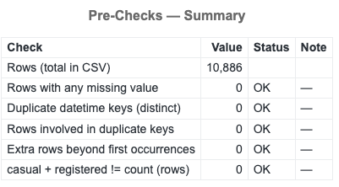
Figure 2: Summary of Pre-Checks
The raw file contains 10,886 rows and passed all front-door validations: no rows with missing values, no duplicate datetime keys (hence no duplicate-involved or “extra” rows to resolve), and the accounting identity casual + registered = count holds for every record. Together, these results indicate a clean, uniquely keyed hour-level table suitable for downstream EDA and inference without corrective preprocessing; any remaining quality work can focus on temporal completeness (gaps), outliers, and distributional assumptions rather than basic data hygiene.

Temperature Anomaly
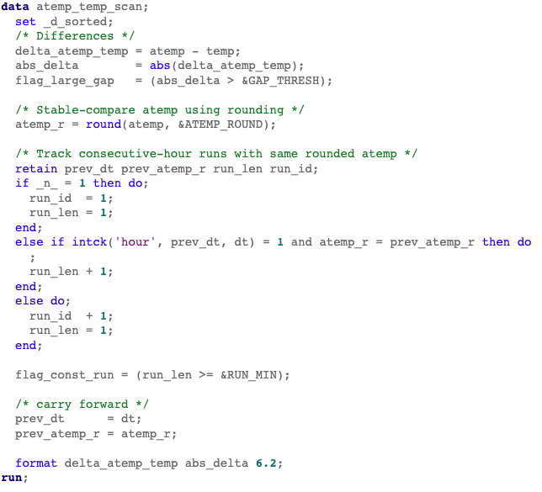
Figure 3: Code snippet for atemp anomaly (Assign1/1_DataPreparation/2_TempAnomaly.sas)
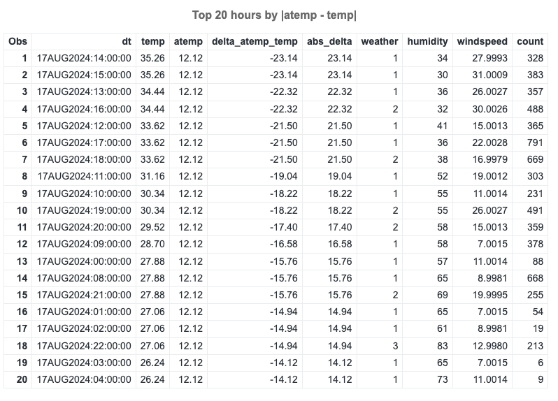
Figure 4: Results of atemp anomaly checks
Using a 10 °C gap threshold and ≥6-hour constant-value rule, the scan surfaced systematic issues with atemp: on 17 Aug 2024, atemp is frozen at 12.12 °C for 24 consecutive hours, producing extreme gaps versus temp (e.g., change up to 23.14 °C) and multiple hours flagged as anomalies; similar constant-atemp runs (10–25 h) appear in other periods as well. A collinearity snapshot shows r(temp, atemp)=0.98495, r²=0.970 and an implied VIF≈33.5 if both are modeled together, it is beyond acceptable limits. Taken together, these results indicate:

- atemp contains anomalies that would skew data
- even when not anomalous, atemp is redundant with temp.

For analysis, atemp will therefore be excluded or imputed in flagged runs, and choose temp to avoid instability from multicollinearity.

Date Time Checks
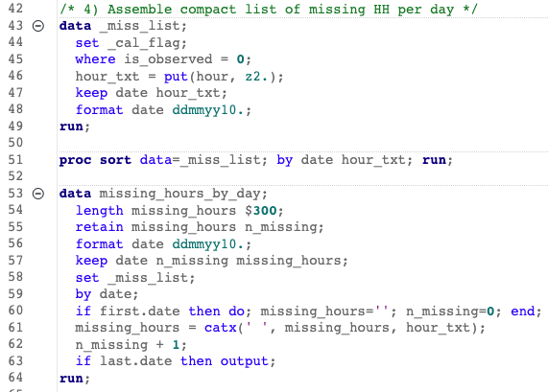
Figure 5: Code snippet of missing hours (Assign1/1_DataPreparation/3_DateTimeCheck.SAS)
A date and hour calendar join shows systematic gaps, with recurring full-day outages (24 missing hours) on the 20th to 31st across many 2023–2024 months and occasional single-hour holes, consistent with source-level truncation rather than random loss. To neutralize these gaps, all summaries use Average Users calculated over observed hours only, and daily comparisons retain all days while relying on the observed-hours denominator to handle uneven coverage. Statistical inference uses tests robust to unequal sample sizes, such as the Welch t test. The coverage denominator is reported for several views and will be added wherever missing so that demand rates, seasonal or weekday effects, and peak analyses remain comparable without downward bias from missing hours.

Weather/Season/Holiday Check
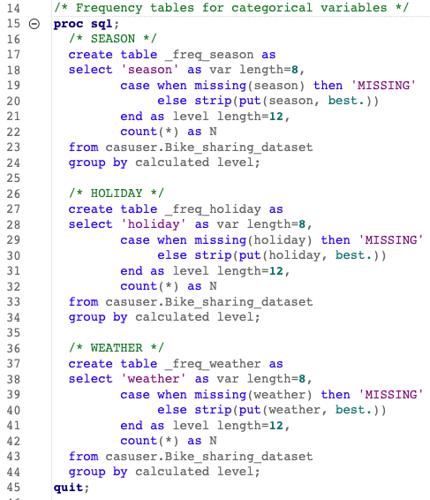
Figure 6: Code snippet of weather, season and holiday checks. (Assign1/1_DataPreparation/4_WeatherSeasonHolidayCheck.SAS)

Season is well balanced across the four codes (about one quarter each), so seasonal comparisons are statistically stable. Weather is concentrated in fair conditions: level 1 accounts for 66.1% of hours, level 2 for 26.0%, level 3 for 7.9%, and level 4 appears only once in the entire sample (one hour on 09/01/2024), which makes extreme weather effectively absent. Holidays are rare at 2.9% of hours overall (2023: 2.7%, 2024: 3.1%), with 6-7 holiday days per year. These profiles imply that holiday should be treated as a rare-event flag, weather level 4 should be grouped with adjacent adverse categories or excluded from inference, and chi-square style tests should verify minimum expected counts or use grouping to maintain validity.

Season Sanity Check

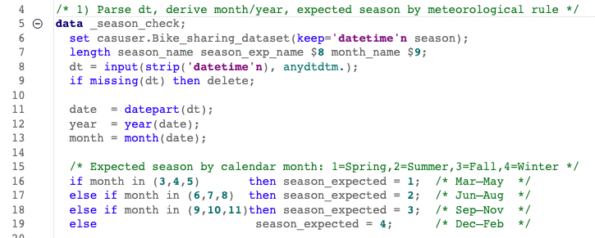
Figure 7: Code snippet for season sanity checks. (Assign1/1_DataPreparation/5_SeasonSanityCheck.sas)
The dataset’s season field aligns with calendar quarters rather than meteorological seasons. Counts place season=1 in January-March, season=2 in April-June, season=3 in July-September, and season=4 in October-December, yielding 100% mismatches in months outside March, June, September, and December when compared to the meteorological rule. Detected change points occur at 00:00 on April 1, July 1, October 1, and January 1, not on March 1, June 1, September 1, and December 1. This indicates a labelling or encoding shift and will be treated as a quarter code and relabel before interpretation.

Target Leakage of Users Count
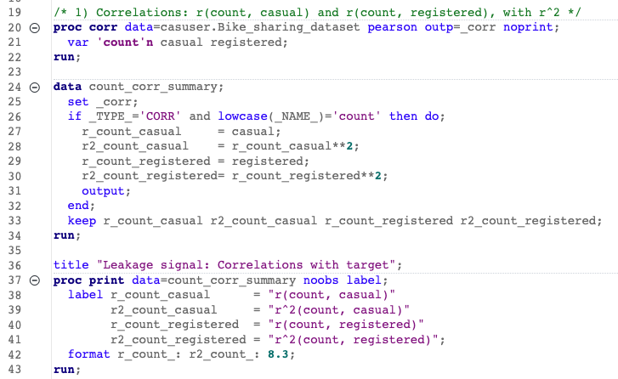
Figure 8: Code snippet for target leakage of users. (Assign1/1_DataPreparation/6_TargetLeakage.sas)
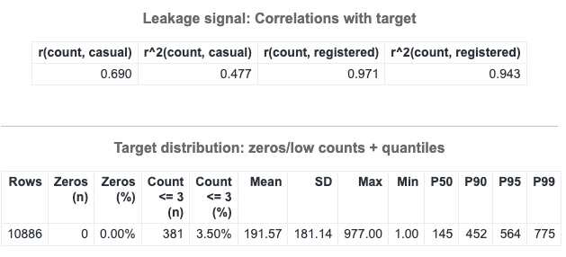
Figure 9: Results for Target Leakage
The identity check confirms no mismatches in count = casual + registered. Correlations show count is dominated by the registered series (r = 0.971, r² = 0.943) and only moderately aligned with casual (r = 0.690, r² = 0.477). The target has no zeros and a pronounced right tail (P50 = 145 users/hour, P90 = 452, P95 = 564, P99 = 775; max = 977), with only 3.5 percent of rows at three users or fewer. Nighttime hours concentrate the very low counts, while commute and evening periods carry the high medians. Composition shares are stable and skewed toward registered riders (median registered share ≈ 0.86; casual ≈ 0.14). Methodologically, casual and registered will be treated as components of the target to avoid using them as predictors with count to prevent leakage.

Weekend Flag
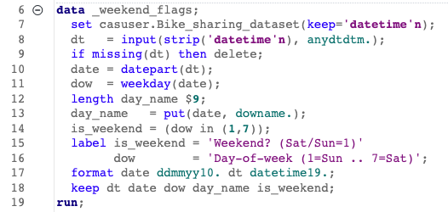
Figure 10: Code snippet for weekend flag. (Assign1/1_DataPreparation/7_WeekendFlag.sas)
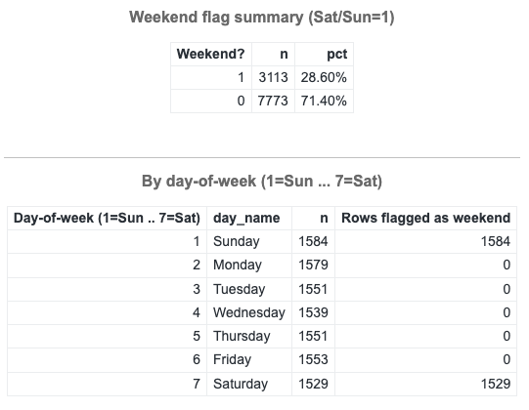
Figure 11: Results of weekend flag script.
Weekend hours (Saturday and Sunday) account for 28.6% of observations (n = 3,113), while weekdays account for 71.4% (n = 7,773). Counts by day confirm correct tagging with all Sunday rows (n = 1,584) and Saturday rows (n = 1,529) are flagged as weekend, with zero weekend flags on Monday to Friday. This validates the Sat/Sun weekend definition for subsequent weekday-weekend comparisons.

Data Transformation
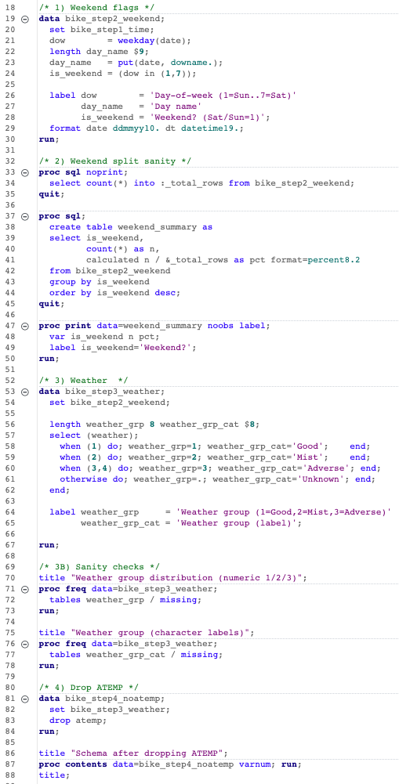
Figure 12: Data Transformation code. (Assign1/1_DataPreparation/8_FinalDataOutput.sas)
This block creates analysis-ready features and removes a problematic field. The timestamp stored as text is parsed into a numeric datetime (dt) and split into date and hour to support hourly models, calendar grouping, and exact joins on a date-by-hour key. A weekend flag (Saturday or Sunday) is derived from the day-of-week so that weekday versus weekend demand can be compared directly and summarized consistently. Weather codes are collapsed into three groups which are Good = 1, Mist = 2, Adverse = 3 or 4, to address extreme sparsity in level 4, improve expected counts for contingency tests, and preserve the fair-versus-adverse contrast needed for ANOVA or rank-based comparisons. The variable atemp is then removed because earlier checks found blockwise constant runs and very high collinearity with temp, which would inflate standard errors and create instability if both were modelled together.

Binning of Variables
Refer to folder: Assign1/2_ExploreVisualize

Temperature was binned in 3-degree bands from 0-3 up to 39-42 to capture smooth curvature and the comfort band visible in the charts, including the local maximum at 30-33 and softening above the high-30s. These narrow bands let the mean profile trace the rise and easing without overfitting to noise.

Humidity was binned in 10-point bands to align with its broad, monotonic effect and to support the 60% reference (Eren & Emre Uz, 2020) that separates high-throughput hours from suppressed demand in the report.

Windspeed was binned in 5-unit steps to distinguish the “calm” dip from the broad mid-range plateau around 10-30 seen in the usage curve.

Season was handled as categorical levels to compare demand across quarters in a way that matches the strong temperature shifts by season.

A weekend type flag enables clean stratification for hour-of-day comparisons and paired tests.

Finally, peak-hour bins group the day into Morning, Midday, Evening, and Off-peak so that the recurring commute band and the broader evening band show up as level differences, which ANOVA and Tukey procedures can test directly. This design also matches the heatmap’s two dominant windows without fragmenting the sample across 24 separate hours.

These choices mirror the empirical patterns and tests presented in the report: the temperature peak at 30-33, the humidity drop, the wind mid-range plateau, the seasonal ordering driven mainly by temperature, and the AM/PM concentration of use.

Data Analyses
Analyses were conducted in SAS Viya. Hypothesis testing used Levene’s test for homogeneity; when variances were unequal, Welch’s ANOVA (Satterthwaite df) was applied with Tukey-Kramer post-hoc comparisons. A 95% confidence level (α = 0.05) was used; results with p < 0.05 were deemed statistically significant and the null hypothesis rejected.

Table analyses used Pearson χ² with observed/expected counts, row/column percentages, and measures of association (e.g., Cramér’s V) to test independence and quantify effect size; expected counts check χ² assumptions, while percentages standardize for marginal imbalances to aid interpretation.

Insight 1: Weather is a clear demand driver

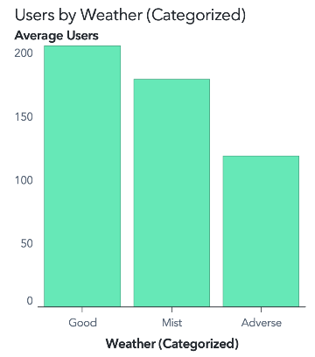
Figure 13: Average Users vs Weather(Categorized)
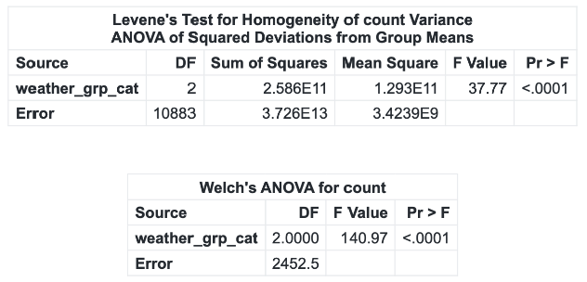
Figure 14: Levene Test and Welch's Anova
H₀: The mean hourly users are equal across weather categories (μ_Good = μ_Mist = μ_Adverse).
H₁: At least one weather category mean differs.

Average users are highest on Good weather days, then Mist, and lowest under Adverse. Welch’s ANOVA (used after Levene indicated unequal variances) shows a significant weather effect, $F=140.97, p<.0001$, with small model fit ($R^{2}≈0.018$); Tukey–Kramer indicates every pair differs (all $p<.0001$). Group means (users/hour) are ≈205 (Good), 179 (Mist), 119 (Adverse), underscoring a material gap between favorable and adverse conditions.

Insight 2: Temperature Distribution differs by Weather

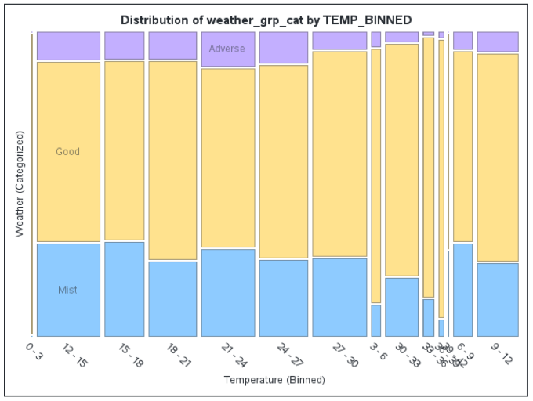
Figure 15: Temperature by Weather(Categorized)

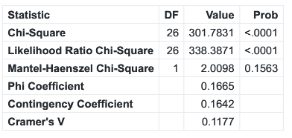
Figure 16: Statistics for Temperature and Weather
H₀: Temperature bin and weather category are independent (no association).
H₁: Temperature bin and weather category are associated (not independent).

Temperature spreads vary by weather: Good clusters around mid-temperatures with tighter IQRs; Mist is broader; Adverse is sparser and more variable. The contingency test TEMP_BINNED by Weather is significant (χ²(26)=301.78, p<.0001), but Cramér’s V=0.118 indicates a weak association which is useful for nuance, not a dominant driver. The observed-vs-expected table supports mid-temperature enrichment under Good and relative under-representation for Adverse in several bins.

Insight 3: Humidity Profile differs by Weather
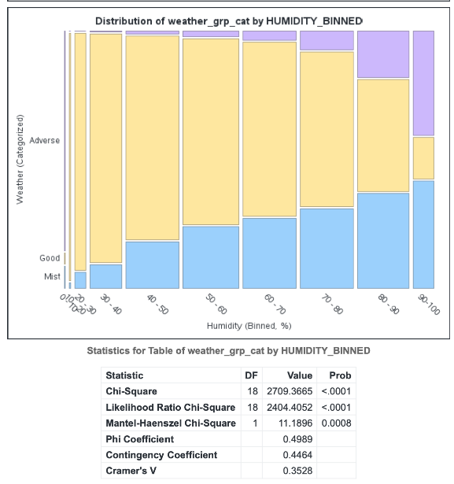
Figure 17: Distribution of Weather Category by Humidity Binned, and its Statistics
H₀: Humidity bin and weather category are independent.
H₁: Humidity bin and weather category are associated.
The humidity profile differs by weather: Good weather concentrates in mid-humidity (≈40–70% RH) with tighter IQRs; Mist shifts slightly higher and broader; Adverse is up-weighted at high humidity (80–100% RH). Pearson’s χ² confirms moderate association (χ²(18)=2709.37, p<.0001; Cramér’s V=0.353), with N=10,886. Observed vs expected counts show mid-band enrichment for Good and over-representation of Adverse in the upper bins.

Insight 4: User and Humidity Association
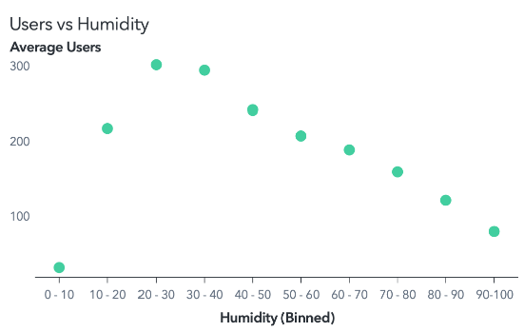
Figure 18: Dot Plot of Average Users vs Humidity

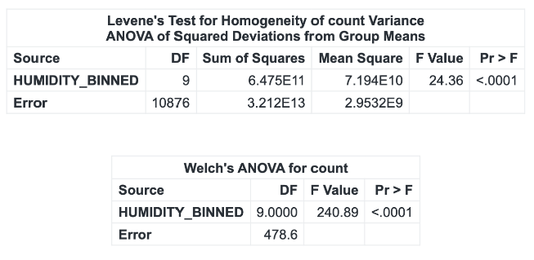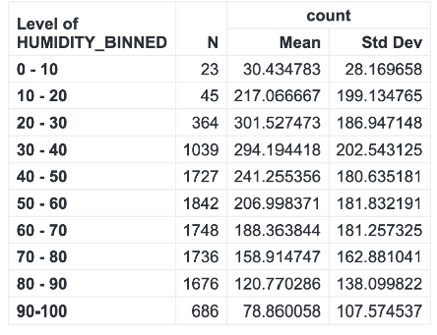
Figure 19: Statistics from ANOVA test
H₀: Mean hourly users are equal across humidity bins (μ₀₋₁₀ = μ₁₀₋₂₀ = … = μ₉₀₋₁₀₀).
H₁: At least one humidity-bin mean differs.
Users peak at 20–30% (≈301.5 users/hr) and 30–40% (≈294.2), then decline monotonically as humidity rises: 40–50% ≈241.3 → 50–60% ≈207.0 → 60–70% ≈188.4 → 70–80% ≈158.9 → 80–90% ≈120.8 → 90–100% ≈78.9. Variances are unequal (Levene p<.0001), so Welch’s ANOVA is primary (F(9, 478.6)=240.89, p<.0001; classical one-way F(9,10876)=150.93, p<.0001; R²≈0.111). Tukey–Kramer shows most adjacent drops are significant, while 20–30 vs 30–40 is not (p≈0.9995), indicating a flat top before the downturn.

Insight 5: Weather Composition Across Windspeeds
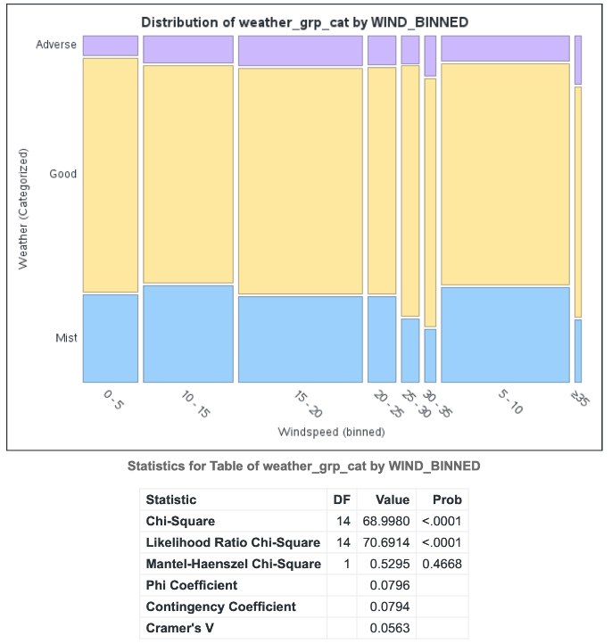
Figure 20: Distribution of Weather by Windspeed Binned, and its Statistics
H₀: Windspeed bin and weather category are independent.
H₁: Windspeed bin and weather category are associated.

Windspeed distributions are broadly similar across weather states, with Adverse showing a slightly higher median and wider spread. The contingency test is significant (χ²(14)=68.998, p<.0001), but the effect is weak (Cramér’s V=0.056). Interpretation: weather mix shifts a bit across wind bands, but not strongly enough to be a major driver.

Insight 6: Mid-Range Plateau for Users vs Windspeed
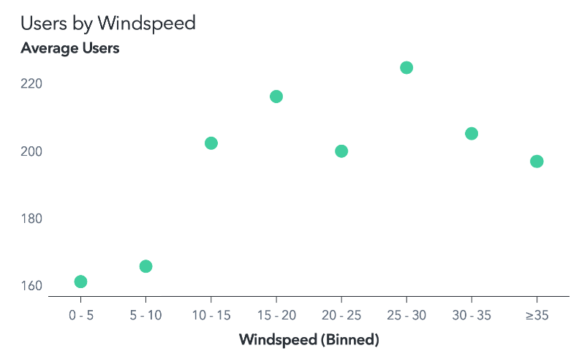
Figure 21: Average Users by Windspeed
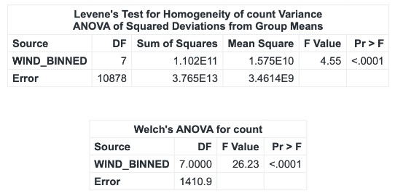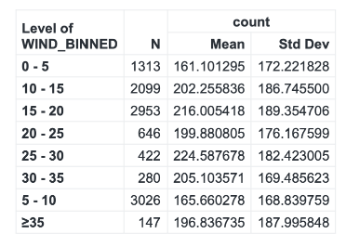
Figure 22: Users by Windspeed ANOVA statistics
H₀: Mean hourly users are equal across windspeed bins (μ₀₋₅ = μ₅₋₁₀ = … = μ_≥35).
H₁: At least one windspeed-bin mean differs.
Average users rise from calm (0–5: ~161; 5–10: ~166) to moderate winds (15–20: ~216; 25–30: ~225), then hover around a mid-range plateau (20–25: ~200; 30–35: ~205; ≥35: ~197). Variances are unequal (Levene p<.0001), so the primary inference uses Welch’s ANOVA, F(7, 1410.9)=26.23, p<.0001 (classical one-way: F=25.71, R²≈0.016). Tukey–Kramer shows the calm bins are lower than many mid-range bins, while several mid-range pairs are not statistically different, consistent with a broad plateau rather than a sharp optimum.

Insight 7: Humidity and Windspeed Association, Temperature is Orthogonal
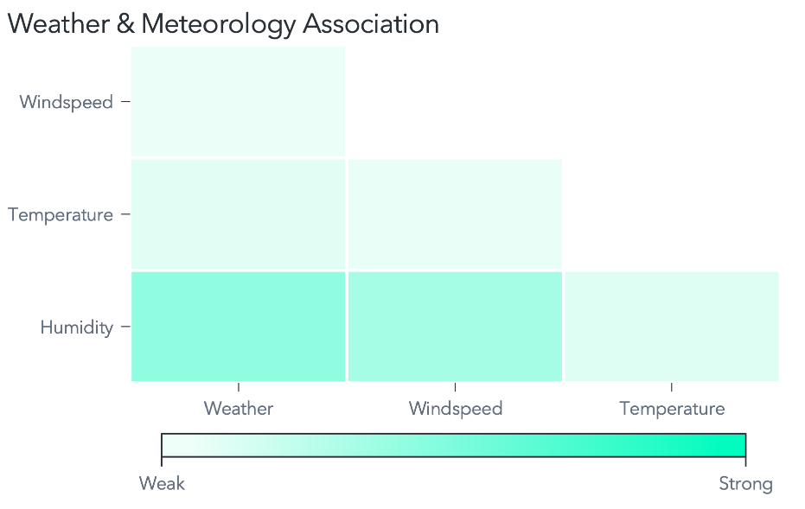
Figure 23: Mosaic plot for correlation
Having established each variable’s association with users, pairwise correlations among temperature, windspeed, and humidity are examined to reveal interdependence that may confound effects. This step clarifies which meteorological factors move together versus independently, sharpening interpretation of drivers of demand and guarding against collinearity-driven misattribution.

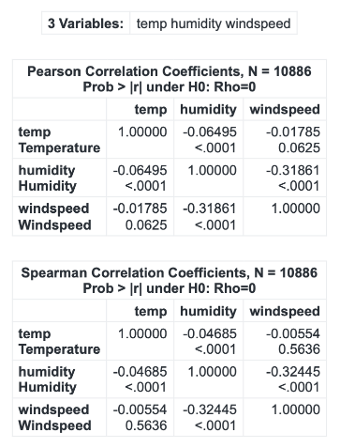
Figure 24: Statistics from Correlation Analysis
H₀: ρ = 0 between each meteorological pair (Pearson/Spearman).
H₁: ρ ≠ 0 between each pair.

Humidity and windspeed are moderately negatively correlated (Pearson r = −0.319; Spearman ρ = −0.324, both p < .0001), indicating windier periods tend to be drier. Temperature shows only a very weak negative tie to humidity (Pearson r = −0.065; Spearman ρ = −0.047, both p < .0001) and is near zero with windspeed (Pearson r = −0.018, p = .0625; Spearman ρ = −0.006, p = .564), implying temperature varies largely independently of wind in this dataset.

Insight 8: Humidity as Primary Driver, Comfort Band for Temperature, Windspeed with Mid-Range Plateau
Given humidity’s consistently strong signal with monotonic declines in users across bins, a moderate composition link to weather, and a negative coupling with windspeed. The analysis now drills deeper into humidity-specific effects. This includes testing practical thresholds (e.g., 60% RH) and a cutoff sweep to pinpoint actionable breakpoints that most affect demand.

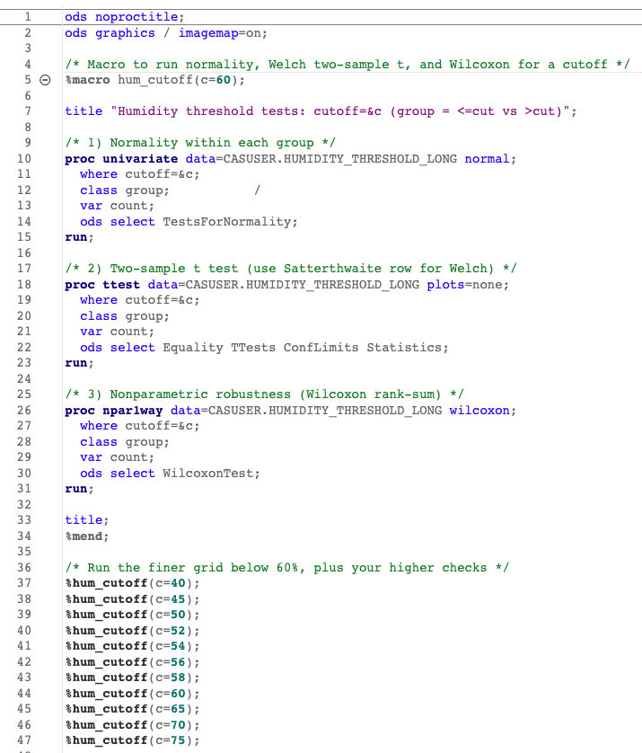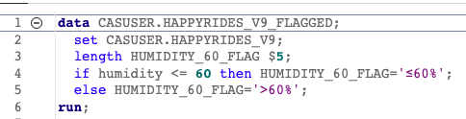
Figure 25: Code snippet for CDA prep (Assign1/3_Confirmatory Data Analysis/5A_HumiditySweepPrep.sas)
Above code chunk was used for the data preparation for this CDA for the Two-sample t Tests. This will find from our dataset which range users started falling off, and aims to check if it conforms with the research paper where users fell off after 60% Humidity.

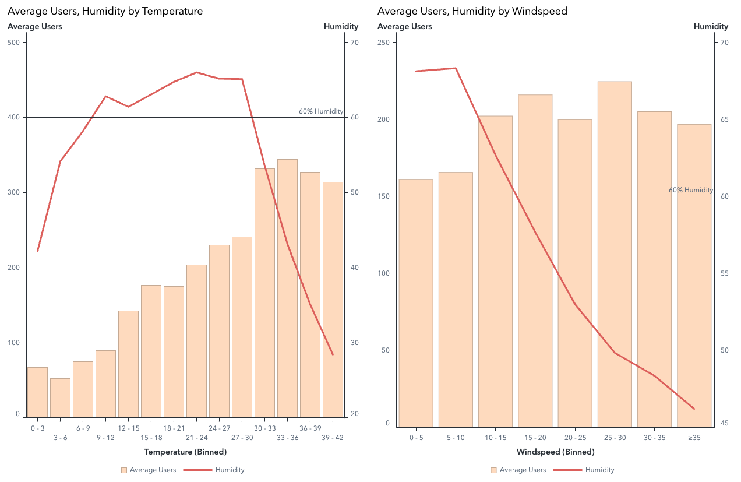
Figure 26: Average Users, Humidity by Temeprature/Windspeed

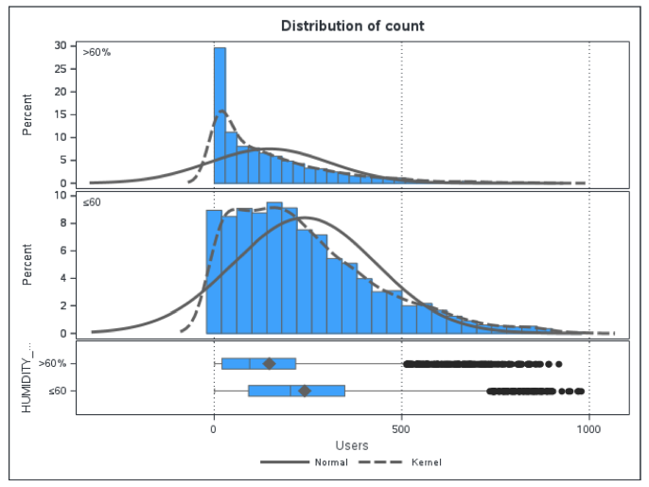
Figure 27: Distribution Count for testing <60% and >60% Humidity
Across the three meteorological factors, humidity shows the clearest monotonic relationship with usage (peak around 20–40% RH followed by steady declines; Welch ANOVA p<.0001), while temperature exhibits a comfort-band peak near ~30–33 °C and windspeed shows a lift from calm to moderate followed by a broad plateau.

Correlation results further indicate a moderate negative coupling between humidity and windspeed and only weak ties with temperature, reinforcing humidity as the most actionable lever and motivating the deeper threshold and sweep analyses.

Insight 9: Seasonal demand ordering tracks seasonal temperature; humidity and windspeed play secondary roles
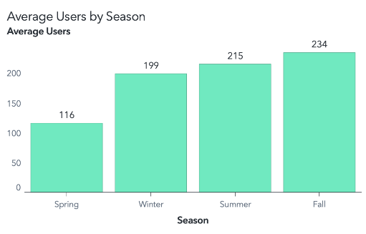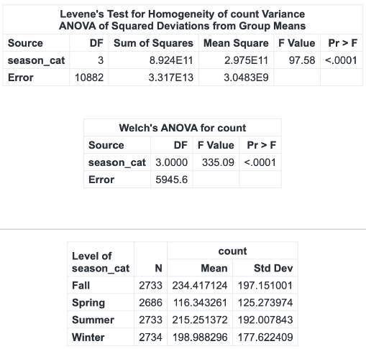

Figure 28: Users by Seasons, with ANOVA Statistics

H₀: Mean hourly users are equal across seasons (μ_Fall = μ_Summer = μ_Winter = μ_Spring).
H₁: At least one seasonal mean differs.

Welch’s ANOVA shows a clear season effect on users, F≈335.09, p<.0001, with means Fall ≈ 234, Summer ≈ 215, Winter ≈ 199, Spring ≈ 116; Tukey–Kramer indicates all pairs differ (R²≈0.061). This ordering aligns with strong seasonal shifts in temperature—Fall ≈ 28.8 °C, Summer ≈ 22.8 °C, Winter ≈ 16.6 °C, Spring ≈ 12.5 °C—where temperature differences are large (Welch F≈6874.04, p<.0001).

Insight 10: Meteorology by Season: Big temperature shifts, modest humidity changes, small wind differences

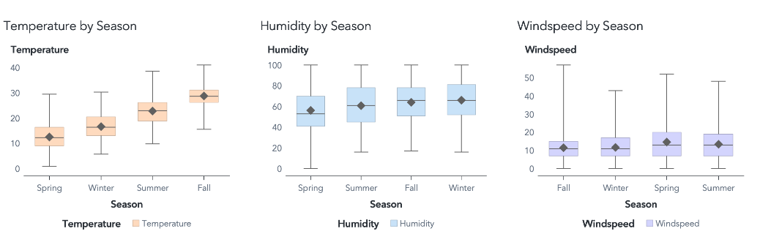
Figure 29: Meteorology by. Season box plots
H₀: Seasonal means are equal for each meteorological variable (temperature / humidity / windspeed).
H₁: At least one seasonal mean differs.

Seasonality is also present in humidity (Welch F≈137.34, p<.0001; Winter ≈ 66%, Fall ≈ 64%, Summer ≈ 61%, Spring ≈ 56%; R²≈0.037) and in windspeed (Welch F≈87.35, p<.0001; Spring highest ≈ 14.64, Fall/Winter calmest ≈ 11.5–11.7; R²≈0.025), but these effects are smaller than temperature’s. Taken together, the seasonal demand pattern mirrors the temperature profile most closely, with humidity and windspeed providing secondary modulation.

Insight 11: Small weekend lead, higher single-hour peak on weekdays

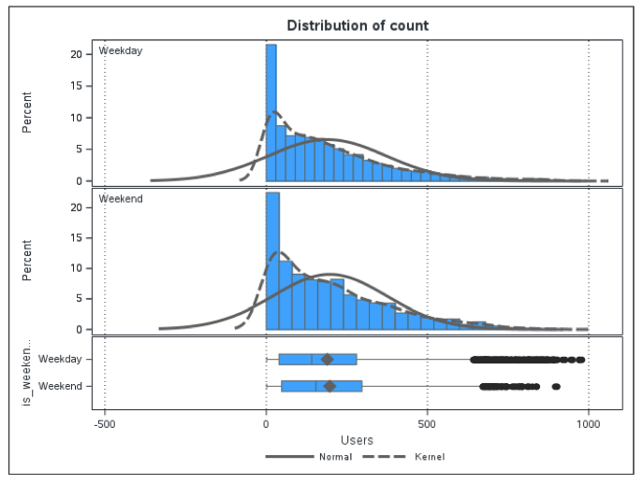
Figure 30: Distribution count of Weekday and Weekend Users
H₀: Mean users (weekday) = mean users (weekend).
H₁: Means differ.

A two-sample comparison was run in SAS Viya with Users (count) as the response and is_weekend as the grouping factor (weekday vs weekend). Weekend averages are slightly higher than weekdays (197.2 vs 189.3 users/hr). Variances differ (Folded-F p≈0.027), so Satterthwaite is primary: t ≈ −2.10, p = 0.036, 95% CI for (weekday−weekend) [−15.37, −0.52]; Wilcoxon corroborates (Z ≈ 3.52, p = 0.0002). Despite the small mean gap, the peak expected hour is higher on weekdays (977 vs 900), implying higher topside provisioning on workdays.

Insight 12: Hour-matched comparison has no overall difference
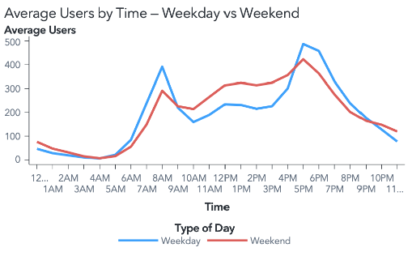
Figure 31: Average Users by Hour, Weekday vs Weekend
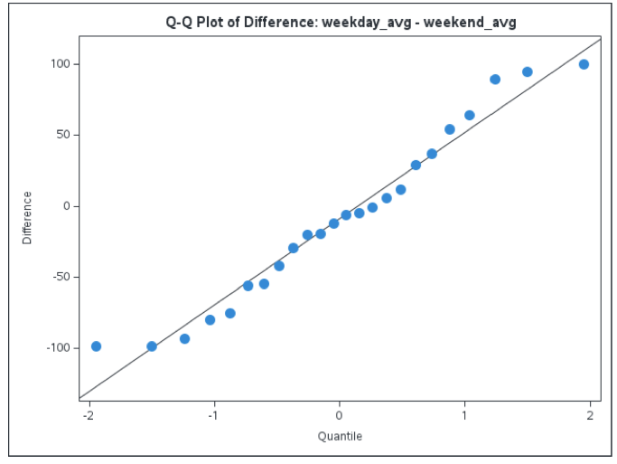
Figure 32: Paired difference if weekend and weekday averages
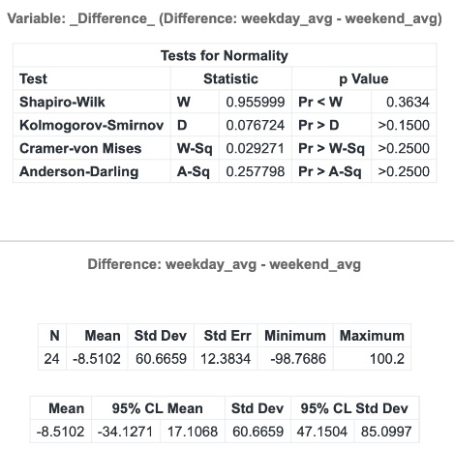
Figure 33: Statistics from Paired Test
H₀: Mean paired difference (weekday−weekend) = 0.
H₁: Mean paired difference ≠ 0.

A paired t-test, normality is checked on the paired differences. Across 24 matched hours, the mean difference is −8.51 users/hr with t(23)=−0.69, p=0.499, 95% CI [−34.13, 17.11] which is not significant. The profile explains this: weekdays concentrate demand into sharp AM/PM commute spikes, while weekends lift later and sustain a broader mid-afternoon plateau, offsetting in the paired average.

Insight 13: Weekday vs Weekend – Registered Users Lead
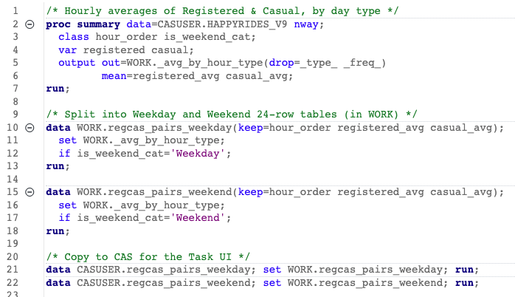
Figure 34: Data Prep for the paired t Test
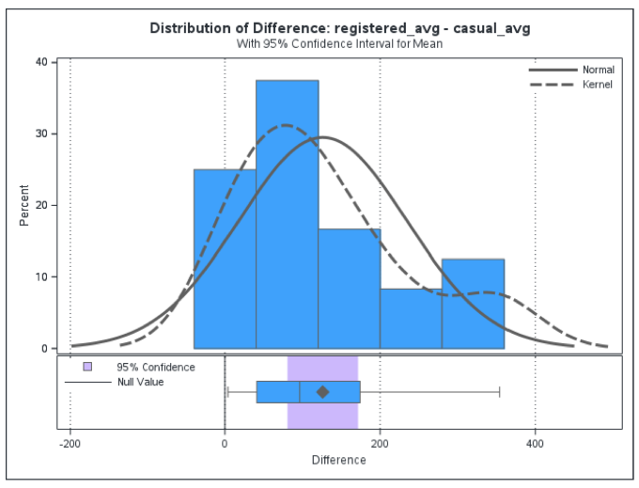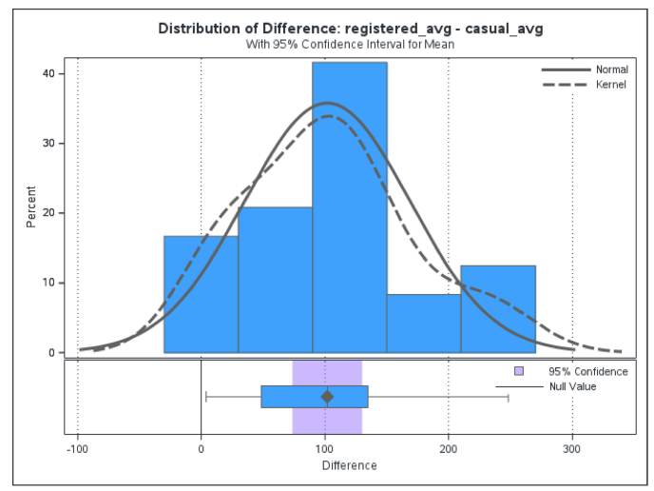
Figure 35: Registered vs Users, Weekend and Weekday Distribution
Weekdays: Normality of the paired differences is adequate (Shapiro–Wilk W≈0.95, p≈0.30). The mean hourly gap is ≈101.8 users/hr; t(23)=7.46, p<.0001 with corroborating sign and signed-rank tests (both p<.0001). Interpretation: on weekdays, the registered segment dominates across the day and drives the pronounced AM/PM commute spikes seen in the lines.

Weekends: Differences are somewhat non-normal (W≈0.88, p≈0.007), so rely on the t-test alongside nonparametrics. The mean hourly gap is ≈125.9 users/hr; t(23)=5.70, p<.0001 with sign and signed-rank tests also p<.0001. Even as casual share expands on weekends (especially mid-afternoon to early evening), registered usage remains higher at most hours, yielding a larger average gap than on weekdays.

Insight 14: Average Users Dominates Evenings, Morning ≈ Midday

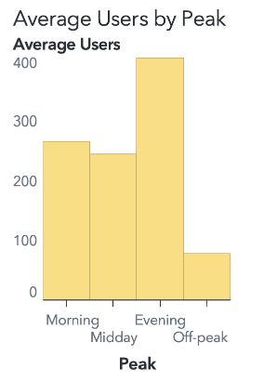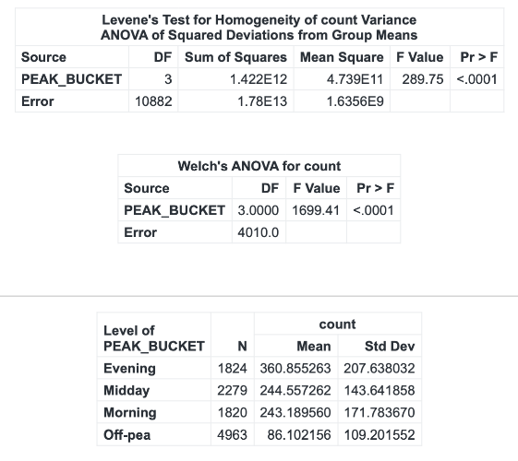
Figure 36: Average Users by Peaks, and Statistics for Anova Tests
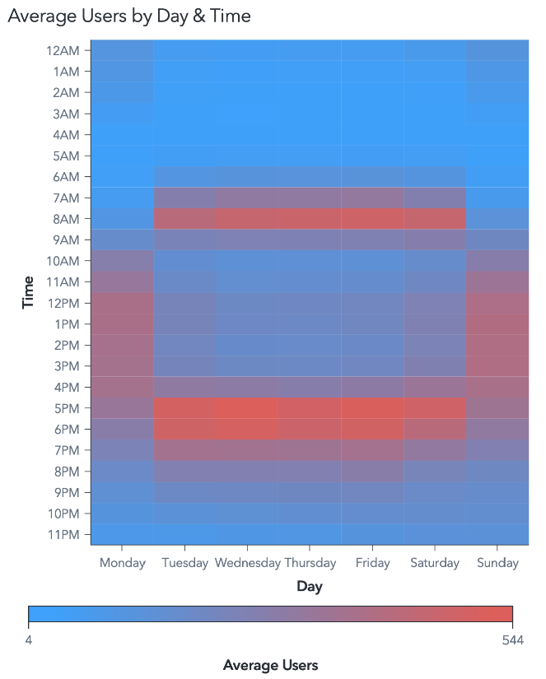
Figure 37: Heatmap of Average Users Day and Time

H₀: Mean users are equal across peak buckets.
H₁: At least one bucket mean differs.

Average users differ markedly across peak buckets: Evening averages 360.9 users/hr and exceeds all other buckets, while Midday (244.6) and Morning (243.2) are statistically indistinguishable and Off-peak is lowest (86.1). Levene indicated unequal variances (p<.0001), so Welch’s ANOVA provides the primary inference (F=1699.41, p<.0001), with a similar classical result (F=1806.08, p<.0001) and model fit R²≈0.332; Tukey–Kramer confirms Evening > Midday and Morning, with Morning ≈ Midday (p=0.9912). These results formalize the heatmap’s commute bands: a weekday morning peak around 7–10 AM and a stronger, broader evening peak around 4–8 PM, while weekends shift the morning lift later (~9–11 AM) and extend the evening window (~5–9 PM).

Insight 15: More users on weekday mornings, no clear weekday and weekend gap in the afternoon.
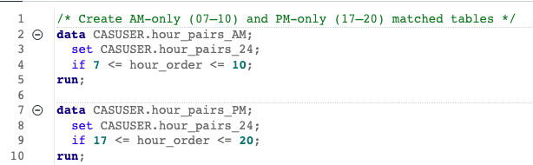
Figure 38: Data prep for morning vs afternoon/evening on weekday weekend. (Assign1/3_Confirmatory Data Analysis/9A_PeakShiftPrep.sas)

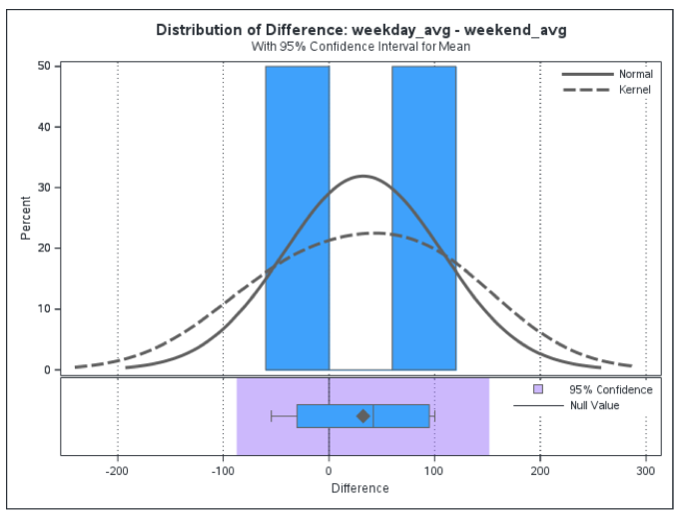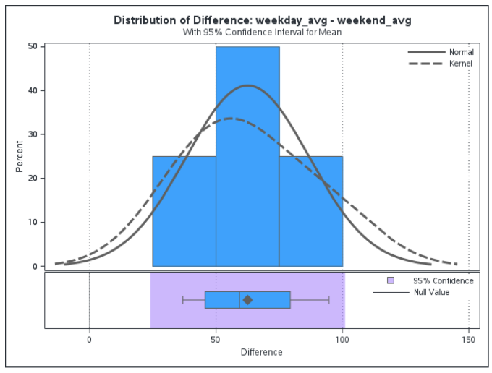
Figure 39: AM/PM vs Weekday Average - Weekend - Average
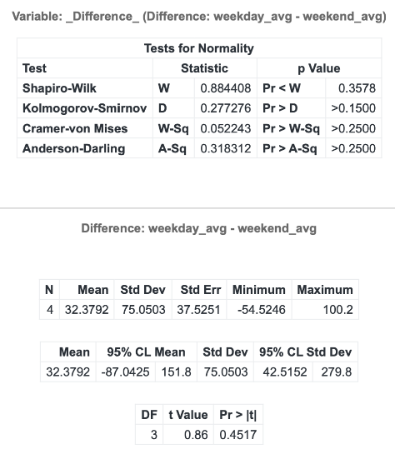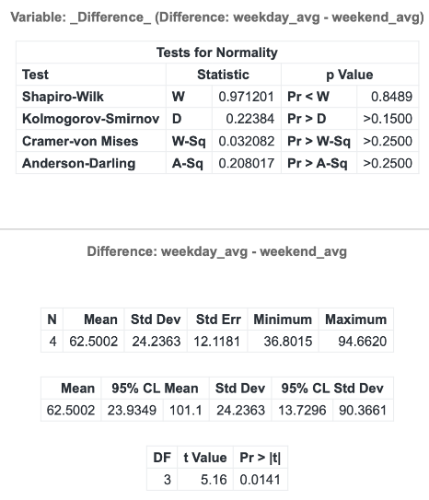
Figure 40: Statistics for AM/PM, Weekday - Weekend Average
H₀: Mean paired difference = 0.
H₁: Mean paired difference ≠ 0.

Paired test was conducted to examine the differences. In the AM window (four matched hours), the weekday–weekend gap is sizeable and statistically reliable: mean difference ≈ 62.5 users/hr, t(3)=5.16, p=0.014, indicating weekday AM > weekend AM even with only four pairs. The corresponding lines show sharp weekday surges around 7–10 AM, consistent with commute-driven demand. In the PM window (four matched hours), the mean difference is ≈ 32.4 users/hr, t(3)=0.86, p=0.452, which is not significant; with such a small n, the test has low power and the confidence interval is wide, so a true modest difference cannot be ruled out. The shape of the curves helps explain the contrast: weekdays exhibit peaky PM usage centered near 4–8 PM, whereas weekends sustain a broader evening plateau (≈ 5–9 PM), flattening the hour-matched difference. Taken together with the peak-bucket ANOVA, the evidence points to commute-specific weekday intensity in the morning and broader, later weekend activity in the evening.

Interpretation of Results: What Drives HappyRides?
Humidity emerges as the dominant weather constraint on demand. The observed monotonic drop in usage at higher relative humidity and the presence of a practical discomfort threshold align with multi-city evidence that humidity suppresses cycling by increasing thermal strain and perceived exertion, often operating in threshold-like rather than strictly linear ways. Recent reviews and case studies describe humidity as a primary deterrent, frequently interacting with other weather to compound discomfort. (Cortez-Ordonez, Vazquez, & Sanches-Espigares, 2024)

Temperature influences demand in a non-linear “comfort-band” fashion. Usage typically rises from cool conditions into a pleasant range and then softens as heat builds, an inverted-U pattern that has been documented for bikeshare and commuter cycling across multiple cities using flexible models. and longitudinal analyses. This shape is consistent with thermoregulatory comfort: modest warmth supports riding, while heat stress reverses gains beyond the comfort zone. (Heaney, Carrion, Burkart, Lesk, & Jack, 2019)

Windspeed plays a secondary, context-dependent role. The data indicate that moving out of very calm conditions is associated with improved usage, after which differences flatten across mid-range winds, a plateau pattern that mirrors findings that wind effects are generally smaller than temperature and humidity, with pronounced deterrence mostly at higher gusts or in combination with other adverse weather. Studies comparing elasticities across variables typically rank wind below temperature and humidity in explanatory power for bikeshare volumes.

Seasonality in demand largely tracks seasonal temperature, with humidity and wind providing modulation rather than wholesale re-ordering. The literature consistently reports higher ridership in warmer seasons and reductions in colder or wetter periods, with temperature shouldering most of the seasonal signal and other meteorological factors acting as amplifiers or dampeners around that baseline. (Wang & Noland, 2021)

Temporal structure explains when usage materializes once meteorology sets the baseline. Weekdays concentrate demand in commute bands, whereas weekends shift activity later and broaden evening use; member/registered riders anchor the weekday peaks, while casual riders expand in leisure windows. These profiles match cross-system observations that commuter-oriented segments dominate weekday peaks and that leisure-oriented segments inflate weekend totals without overturning member dominance. (Yang, Brakewood, Nicolas, & Sion, 2019)

Managerial Communication
The analysis assessed meteorological factors, temporal structure, and rider segments.
A more honest and complete analysis would be possible by incorporating the following enhancements:

Hourly Completeness
Ensuring hourly completeness on a canonical clock is foundational. The table should contain exactly 24 rows per service day (00:00–23:00). This prevents hidden bias from storm hours or overnight gaps and stabilizes all commute-window metrics and averages. With a consistent time base, comparisons by hour, weekday/weekend, and seasonal windows reflect true behavior rather than data collection artifacts.

Precipitation
Precipitation magnitude and duration are among the strongest short-horizon demand suppressors, add continuous fields for intensity and exposure time while retaining the human-readable weather category. Distinguishing mist/drizzle from sustained or heavy rain meaningfully improves fit and makes hour-ahead planning more actionable (e.g., differentiating a brief shower from a prolonged downpour during the evening peak).

Thermal-Confort Indices
Given the dominant role of humidity, derive thermal-comfort indices that jointly capture heat and moisture (e.g., heat_index_c). These measures align naturally with the observed threshold behavior (e.g., the 60% RH trigger) and reduce the risk of misattributing humidity-driven discomfort to temperature alone. Including comfort indices alongside raw temperature and humidity supports clearer narratives and more stable segment comparisons.

Event Calendar
Embed calendar and event context directly in the dataset with is_holiday, school_term, and major_event flags at the relevant geography. This structure explains systematic exceptions such as holiday morning softness, school-term commuter surges, or event-driven evening spikes, and increases forecast specificity for particular dates without post-hoc adjustments.

Bike Dock Stations
Finally, incorporate supply and constraint markers to separate true demand changes from operational limits. For station systems, persist bikes_available and docks_available; for free-floating systems, include a rebalance_flag and service_zone. These fields prevent weather or season from being blamed when a trough is actually a stockout or a temporary service restriction which is critical for accurate attribution and for sizing interventions.

References
Cortez-Ordonez, A., Vazquez, P.-P., & Sanches-Espigares, J. A. (2024). Features that influence bike sharing demand. Heliyon, Volume 10, Issue 18.
Heaney, A., Carrion, D., Burkart, K., Lesk, C., & Jack, D. (2019). Climate Change and Physical Activity: Estimated Impacts of Ambient Temperatures on Bikeshare Usage in New York City. Environ Health Perspect, doi: 10.1289/EHP4039.
Wang, H., & Noland, R. (2021). Bikeshare and subway ridership changes during the COVID-19 pandemic in New York City. Transp Policy, doi: 10.1016/j.
Yang, S., Brakewood, C., Nicolas, V., & Sion, J. (2019). Bikeshare Users on a Budget? Trip Chaining Analysis of Bikeshare User Groups in Chicago. Sagepub, DOI: 10.1177/0361198.
Eren, E., & Emre Uz, V. (2020). A review on bike-sharing: The factors aﬀecting bike-sharing demand. Sustainable Cities and Society.

